Laser Cat

Official Technical Design Document

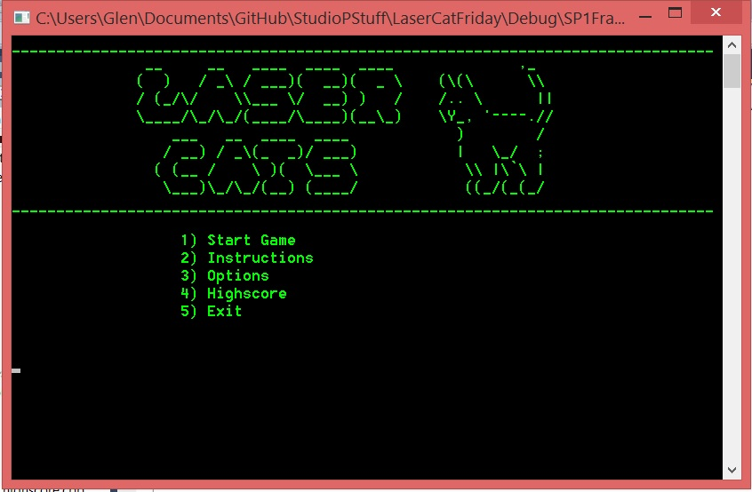

Copyright 2014 by Team 18

A Game Proposal By:

143343M Lim Wei Heng,

140522J Almeda Glenn Paolo Maestro,

143182M Toh Yi Fun Troy,

142471B Brandon Tan.

Table of Contents

Initial Proposal ------------------------------------------------------------------------ 4

Final Proposal ------------------------------------------------------------------------- 7

Game Guide --------------------------------------------------------------------------- 21

Reference Acknowledgements --------------------------------------------------- 22

Initial Proposal

Game Description

* Player is tasked to evade the cat paws by constantly moving the laser pointer.
* Player has up to a set number of health and the game ends when health is completely depleted.

Game Influences

* Laser Pointers
* Cat Behaviours

Features of Game

* Must-haves
  + A dot to represent laser pointer
  + Circles of varying sizes to the cat paws
* Good-to-haves
  + Graphical quality (different picture each movement)
  + As time goes by, the cat paws should move at a faster rate

List of Tasks to Achieve Features

* Main Features
  + Mapping out coordinates where player can move
  + Programming the randomized cat paws attacks
  + Health and scores
* Broken down to smaller tasks
  + Mapping out coordinate where player can move
    - Create a dot (or a set of dots) to represent the player
    - Allow the player to move anywhere
  + Programming the cat paws
    - Create a cat paws based on ASCII symbols
    - Make the cat paws appear at randomized times and areas
  + Health and scores
    - Game ends when player loses all health points
    - Gameplay gets faster at a set interval

Rating of Task Difficulty

* Rating of difficulty tasks is Small (S), Medium (M) and Large (L).
* Main Features
  + Mapping out coordinates where player can move
    - Large (L)
  + Programming the cat paws
    - Large (L)
  + Health and scores
    - Large (L)
* Broken down to smaller tasks
  + Mapping out coordinate where player can move
    - Create a dot (or a set of dots) to represent the player
      * Small (S)
    - Allow the player to move anywhere in the plane
      * Medium (M)
  + Programming the cat paws
    - Create a cat paw based on ASCII symbols
      * Medium (M)
    - Make the cat paw appear at randomized timing and areas
      * Medium (M)
  + Health and scores
    - Game ends when player loses all health points
      * Medium (M)
    - Gameplay gets faster after a set interval
      * Large (L)
  + Additional Features
    - Improve graphics quality
      * Large (L)

Estimation of Time Required to Complete Tasks

* Rating of difficulty tasks is Small (S), Medium (M) and Large (L)
* Based on the difficulty rating, the number of hours will be reflected as a rough guide:
  + Small (S) = 10 hours or less
  + Medium (M) = More than 10 hours but less than 20 hours
  + Large (L) = More than 20 hours
* Main Features
  + Mapping out coordinates where player can move
    - More than 20 hours
  + Programming the cat paws
    - More than 20 hours
  + Health and scores
    - More than 20 hours
* Broken down to smaller tasks
  + Mapping out coordinate where player can move
    - Create a dot (or a set of dots) to represent the player
      * 10 hours or less
    - Allow the player to move anywhere in the plane
      * More than 10 hours but less than 20 hours
  + Programming the cat paws
    - Create a cat paw based on ASCII symbols
      * More than 10 hours but less than 20 hours
    - Make the cat paw appear at randomized timing and areas
      * More than 10 hours but less than 20 hours
  + Health and scores
    - Game ends when player loses all health points
      * More than 10 hours but less than 20 hours
    - Gameplay gets faster after a set interval
      * More than 20 hours
  + Additional Features
    - Improve graphics quality
      * More than 20 hours

Final Report

Game Concepts

- Game Concept

- Genre

- Retro 1980s Handheld Game

- Game Goals

- To allow players of the modern era experience the previous era of gaming

- Have a basic understanding on cat behaviour (i.e. Cats get excited easily over moving objects)

- Application of knowledge into a game

- References

- Cat behaviour

- Laser pointers

- Octopus (1980s game)

Story

- Genre

- Classical LCD game

- High Concept

- Players will play with the cats using their laser pointer.

- Synopsis

- You have decided that it is time to play with your cat. Using your laser pointer, you attract its attention with its bright light. Pulled by its magnificence, it starts to chase after it and it is up to you to keep it occupied by avoiding its impulsive attacks.

Gameplay

- Overview

- This section elaborates on general mechanics of the game.

- Abilities and Controls

- Basic Controls

- Directional pad to move the laser pointer.

- Laser pointer is represented as six red ‘0’s in a 3x2 rectangle.

- HUD

- Health Points is displayed on the top left corner of the screen

- Current Score is displayed on the top right corner of the screen

User Interface

- Overview

- Five main UI screens will be used: Main Menu Instructions, Options and High Scores and Game Over.

- Game Flow

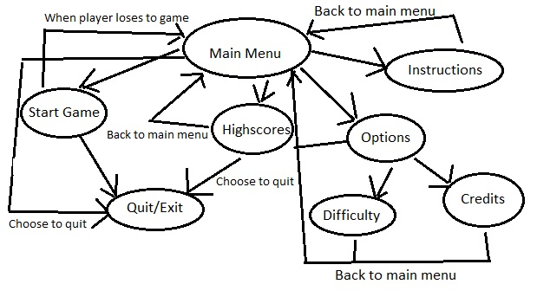

- This is a general outline on how the game will flow from one window to another.

- Main Menu

- This screen will host the following options: Start Game, Instructions, Options, High Scores and Exit screens.

- User is expected to enter a number to define the choice given.



- Instructions

- This screen teaches the player on how to play the game, and tells of the power-ups and hazards the player will face.

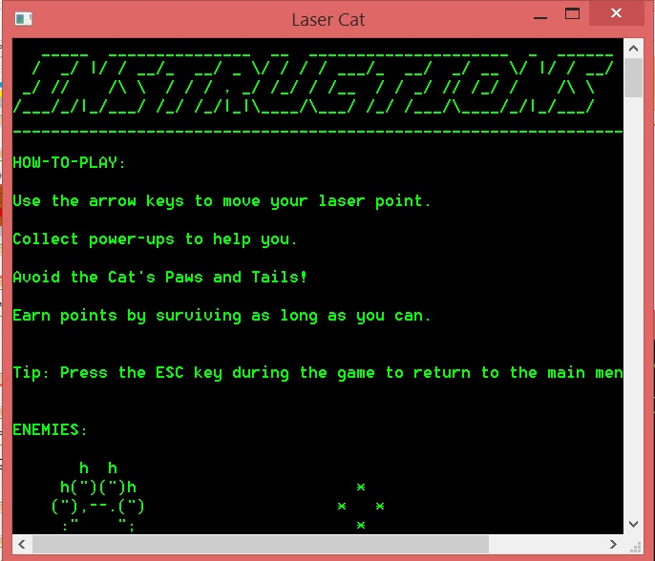

- Game

- This screen is the main gameplay of the game. The player will get to play the game until he loses all his health points or he decides to quit the game.

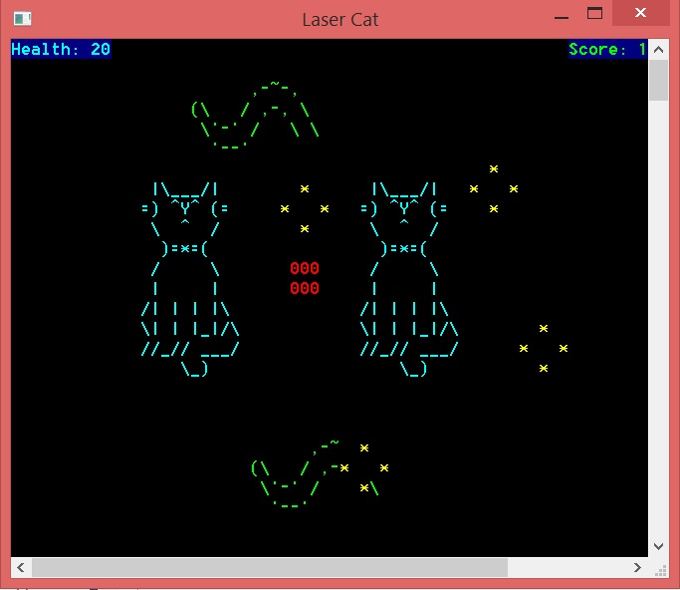

- Options

- This screen will lead to the following options: Difficulty settings and Credits. 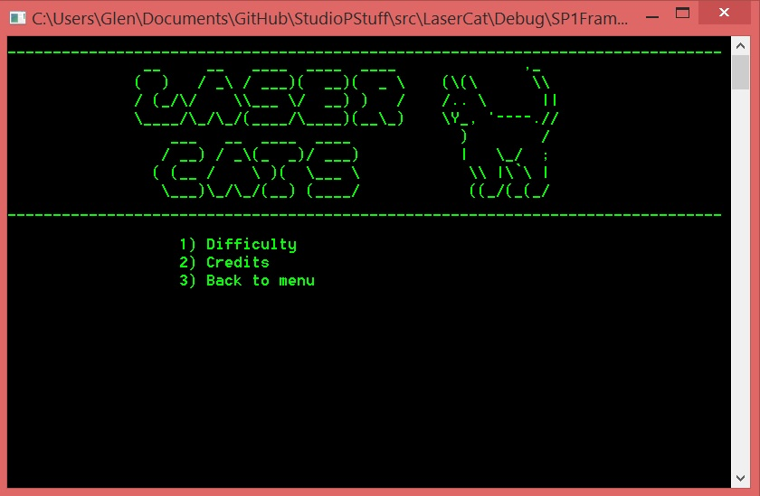

- Difficulty allows the player to choose between two modes: Easy or Hard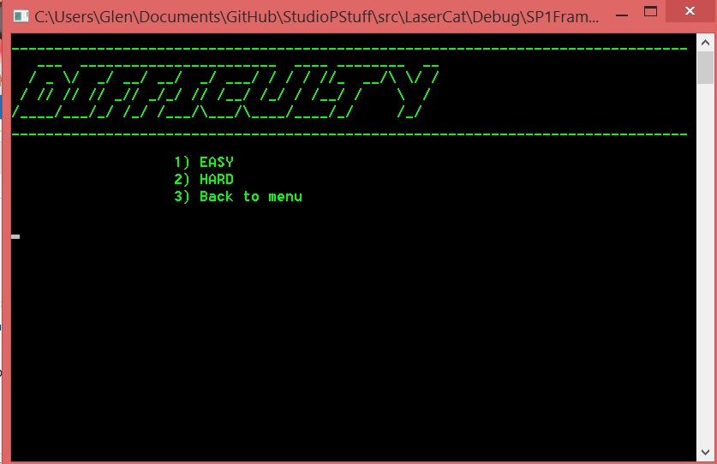

- Credits show the names of the development team behind the game.

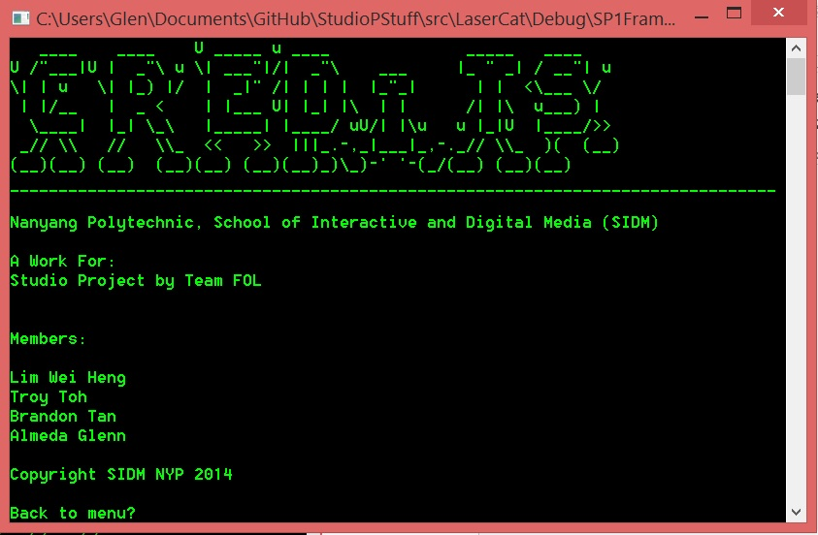

- High Scores

- This screen shows the player the high scores achieved by the people before this.

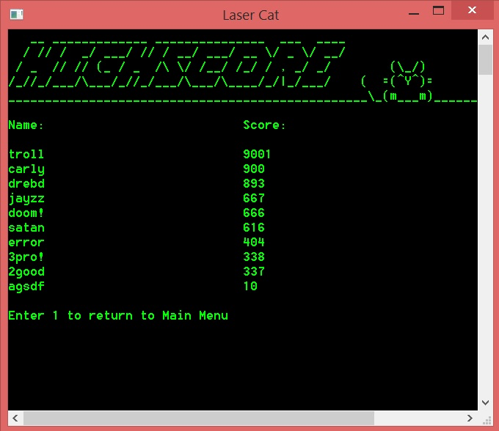

- Game Over

- This screen shows the player loses all health points. If he managed to beat the highscores, he will be prompted to add in his name.

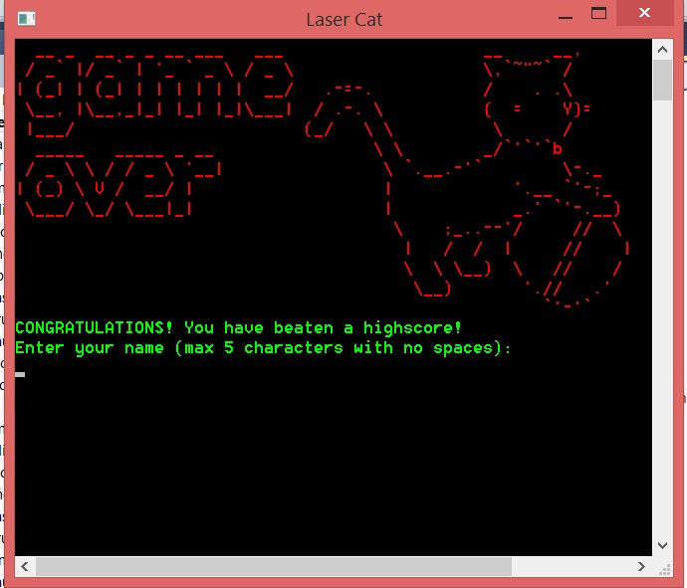

Technical Design

- Overview

- To create the game, we made use of mainly two software: Microsoft Visual Studios 2010 and Notepad

- Microsoft Visual Studios 2010

- All the programming tasks has been in this platform.

- The framework provided (SP1) was used and modified to fit the final product of the game.

- Notepad

- This software is used mainly for aesthetics-related themes of the game.

- This is done to reduce the need to hard code so as to make modifications easier to handle.

11

- Animation

- Overview

- This section elaborates on the animation schemes used in this project

- ASCII Art

- Codes related to the ASCII family is used to provide visual appeal. Most art is related to the cat with the exception of the player’s laser pointer

- Colour Coding

- Colours are used to help indicate the current game status to the player.

- User Interface

- A set of colours was chosen to help identify Health Points and Score. Depending on the chosen difficulty, the score will either increase slowly or quickly, based on elapsed time.

- If the player gets hit by the cat tail or cat paw, the Health Points will deplete for as long as it is touching the tail/paw.

- Frames per second

- Expected amount of frames per second is 5. Certain flickering effects are expected but it should not affect the gameplay adversely.

- Rewards

- Overview

- The score is increased according to selected difficulty.

- The score can be influenced by a certain power ups

- The cat paw will move at random positions of the game space in a progressive manner.

- Power ups

- There are three power ups – Health, Immobilize and Invincibility

- Health adds current health points to player by 10 but is capped at 50 health points at any one time

- Immobilize will force the player to freeze on the spot but will have their score drastically increased.

- Invincibility will allow the player to move anywhere and ignores any damage received by cat tail or paw. Lasts for 2 seconds.

- Sound

- FX

- Beeping sounds upon selecting different options in the menu.

- Default pitch from SP1 Framework is used when player is moving

- Higher-pitched beeping if the player touches a hazard as well as gaining power-ups

Directory

* Overview
  + This section contains information where the files are located
* The Framework folder holds the basic framework of the game. Inside are console.h, timer.h, console.cpp and timer.cpp. This is the main framework used by the SP1 Framework.

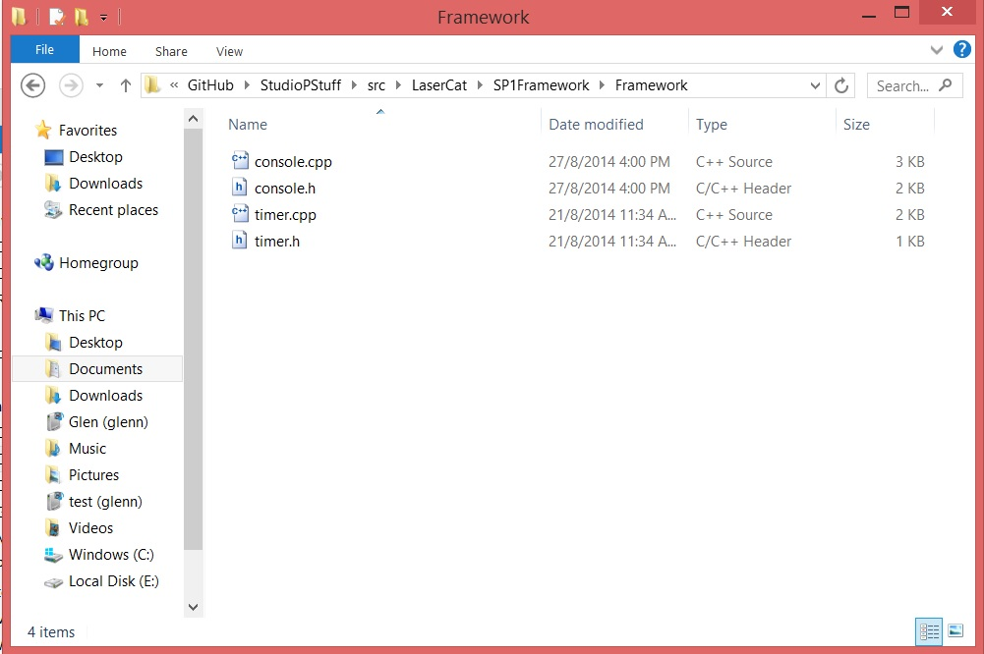

* The rest of the programs used is placed outside of the Framework folder.

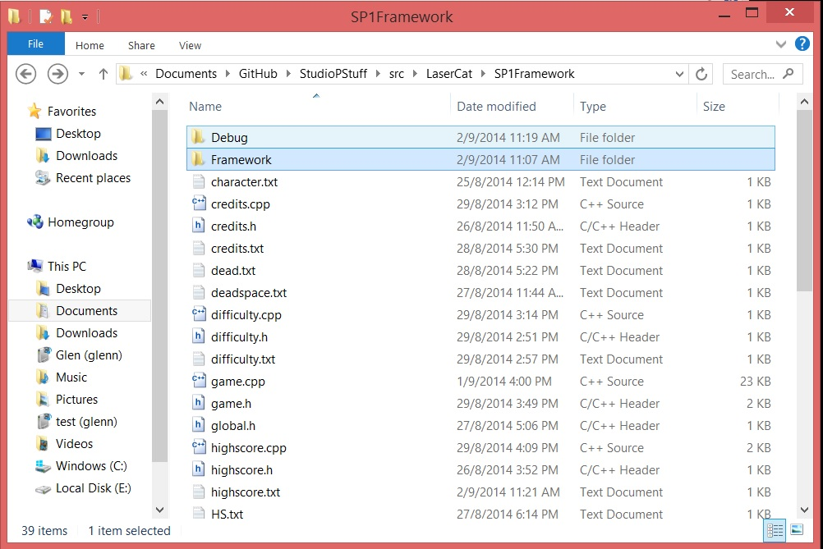

* + The following header files are expected to be found in this file:
    - Credits.h
    - Difficulty.h
    - Game.h
    - Global.h
    - Highscore.h
    - Instructions.h
    - Menu.h
    - Options.h
  + The following CPP files are expected to be found in this file:
    - Credits.cpp
    - Difficulty.cpp
    - Game.cpp
    - Highscore.cpp
    - Instructions.cpp
    - Main.cpp
    - Menu.cpp
    - Options.cpp
  + The following text files used to provide the graphics via ASCII characters arranged to form art are:
* Character.txt
* Credits.txt
* Dead.txt
* Deadspace.txt
* Difficulty.txt
* Highscore.txt
* HS.txt
* Instructions.txt
* Item.txt
* Item1.txt
* Item2.txt
* Item3.txt
* Lpaw.txt
* Mpaw.txt
* Options.txt
* Spaw.txt
* Tail.txt
* Title.txt

- Development

- Overview

- The development of the game is documented in this section.

- Initial Gameplay

- This is when our game production was in its early stages. We established the fundamentals of the game here.

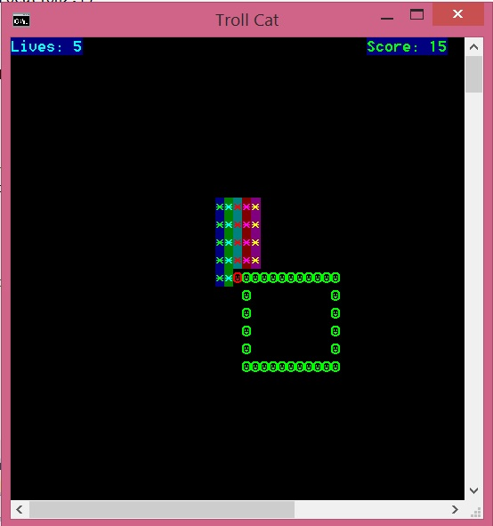

* Red dot = Player’s position
* Green square = Danger zone
* Coloured square = Dead zone (players cannot access this area)
* Second Version of Gameplay  
  - The game mechanics and aesthetics have been improved.

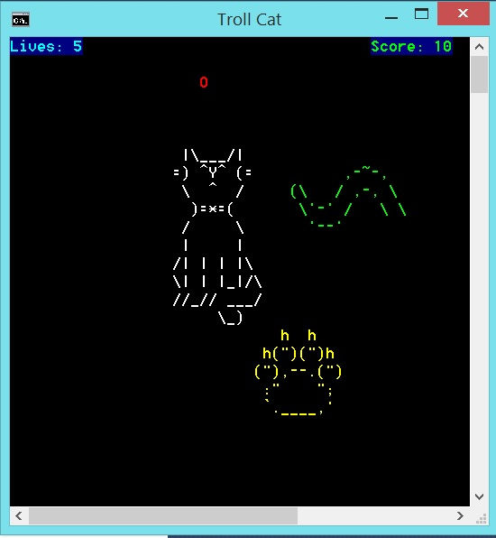

* Game Over screen
  + We also included the “Game Over” component when all lives have been depleted

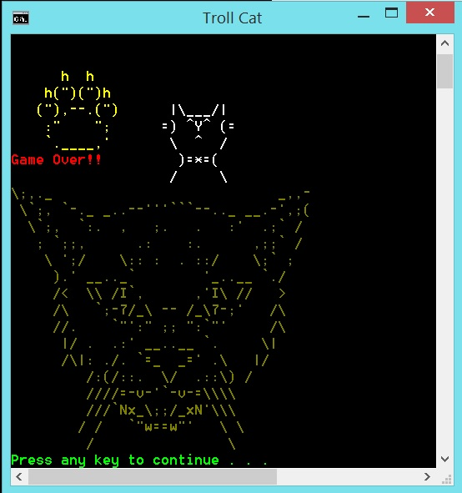

* Final Product
  + The general sense of difficulty and the indicator for player’s life has been changed to health and increased to help improve game flow.

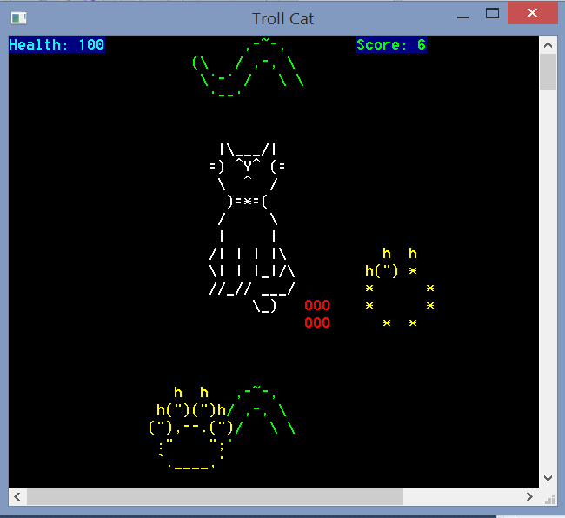

Game Guide

* Overview
  + This section will provide some information to help players to get started.
* Basics
* Your character sprite is **the bright red rectangle**.
* Use the **arrow keys** to move around.
* The **growing circles** are the shadow of the cat’s paws. They don’t hurt you, but **warn** you of their incoming presence.
* Tails are constantly **sweeping** the area. They will hurt you if you touch them. Avoid.
* Small power-ups **will constantly appear**. Each will grant you five points and an additional effect.
* Basic Tactics
* Despite the constant danger, you must **know when to move, and when to freeze**.
* **Power-ups** are there for a reason. Always be on the lookout for them, as they give you five points each when you pick them up in addition to their effects.
* Always keep your health **as high as** you can, even if you have to sacrifice some of it. Some health gained is better than none.
* Advanced Tactics
* Carefully judge whether it is a good idea to pick up the phase or **immobilise power-up**. The points you can gain without them may be more than you can earn after getting them.
* There are a few **blind spots** for the tails where they do not sweep. Make use of them for a quick immobilise if you feel lucky.
* Do not **rely** on the blind spots for quick breathers. The random cat paws may swarm the place, forcing you into the tails’ path.

References Acknowledgements

* Overview
  + This section is to acknowledge sources used in the presentation slides

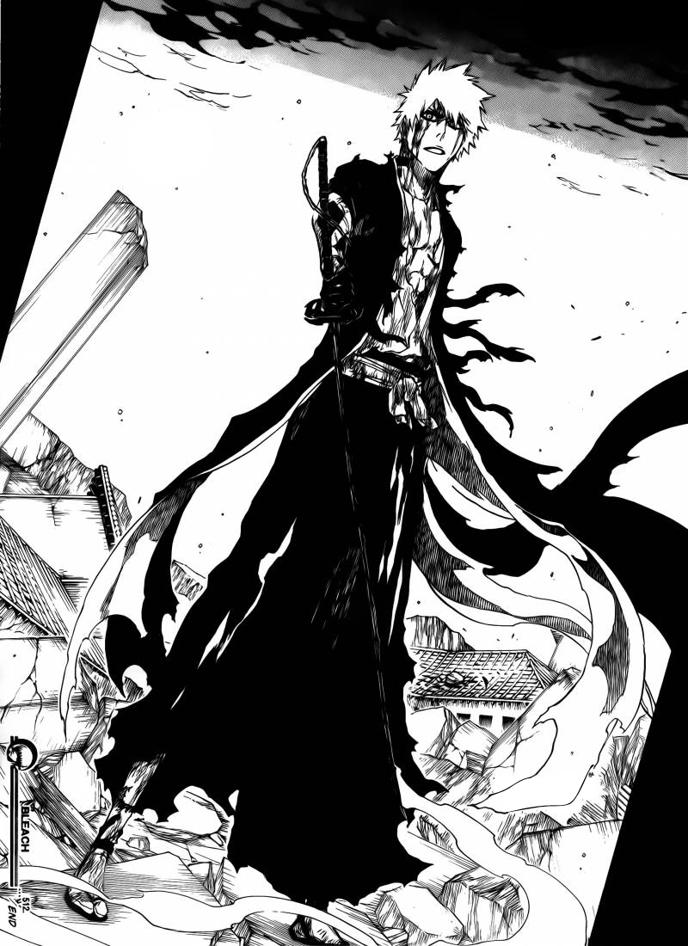

Source: <http://img3.wikia.nocookie.net/__cb20121221233722/bleach/en/images/f/f4/Ch512IchigoDejaVu.png>



Source: <http://www.truthdig.com/images/cartoonuploads/five_generals_500.jpg>



Source: <http://4.bp.blogspot.com/-JlXcsaSbSGM/UVMtjQTpirI/AAAAAAAAAzk/RRN0lTW8P8A/s1600/GARFIELD.jpg>



Source: <http://images5.fanpop.com/image/photos/29000000/Cyclops-x-men-29088946-1024-768.jpg>

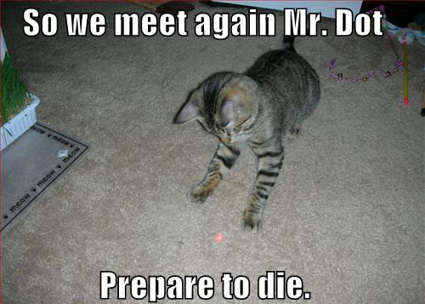

Source: <http://techtrify.com/wp-content/uploads/2011/05/catlaserjpg.jpg>



Source: <http://media.playpark.net/MapleStory/uploadimages/Angelic_Adoration_Chair_Magic_Carpet_Mount.png>

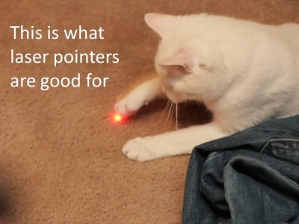

Source: <http://2vga1o5mew51s6gu7x0mnk7kf.wpengine.netdna-cdn.com/wp-content/uploads/main/2013_06/White-Cat-Chasing-Laser.jpg>

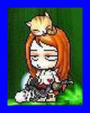

Source: <http://hiroku.files.wordpress.com/2008/11/f3-small.jpg?w=490>

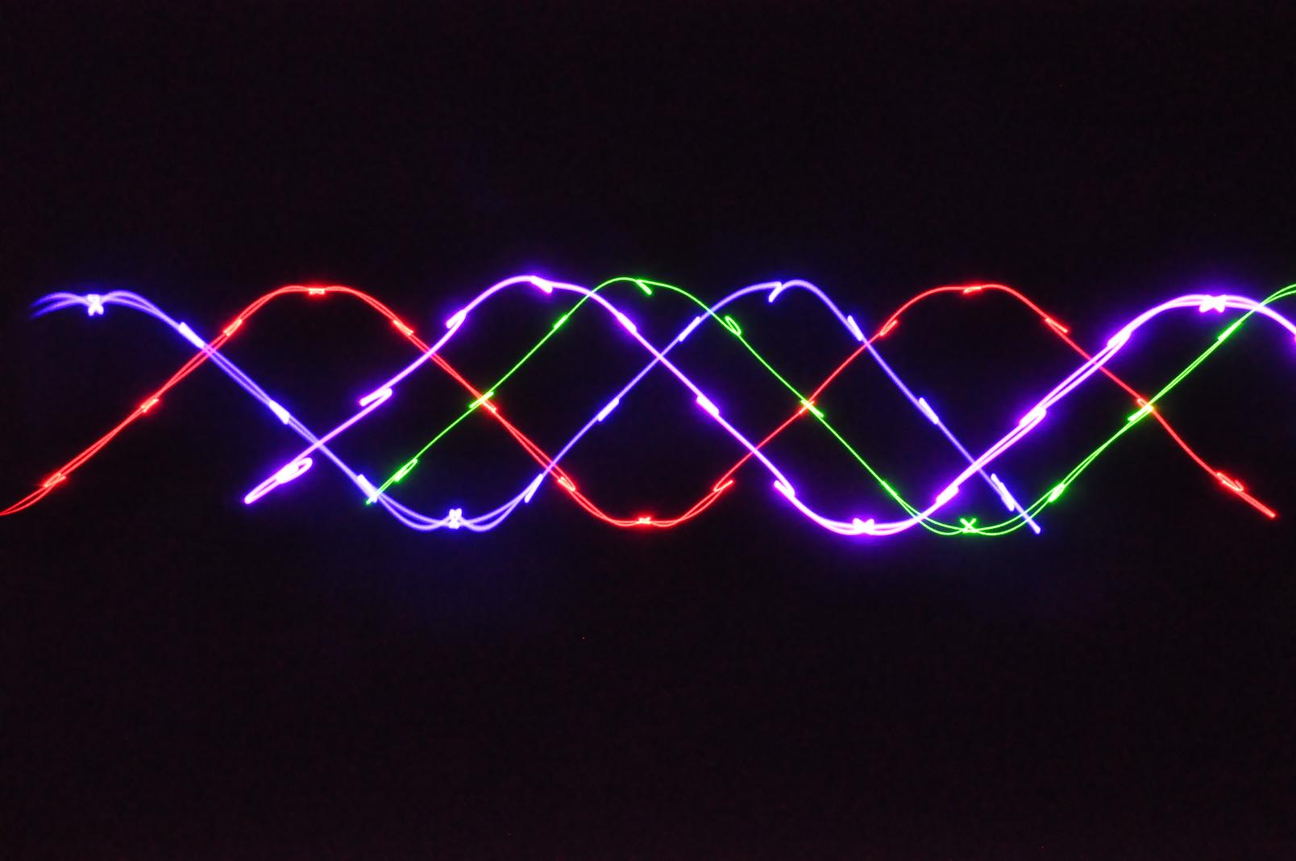

Source: <http://www.studiodopey.nl/wp-content/uploads/2014/01/650mw-Rgbp-Four-Tunnel-Laser-DJ-Light-Disco-Lighting-Club-Light-D650RGBP-.jpg>

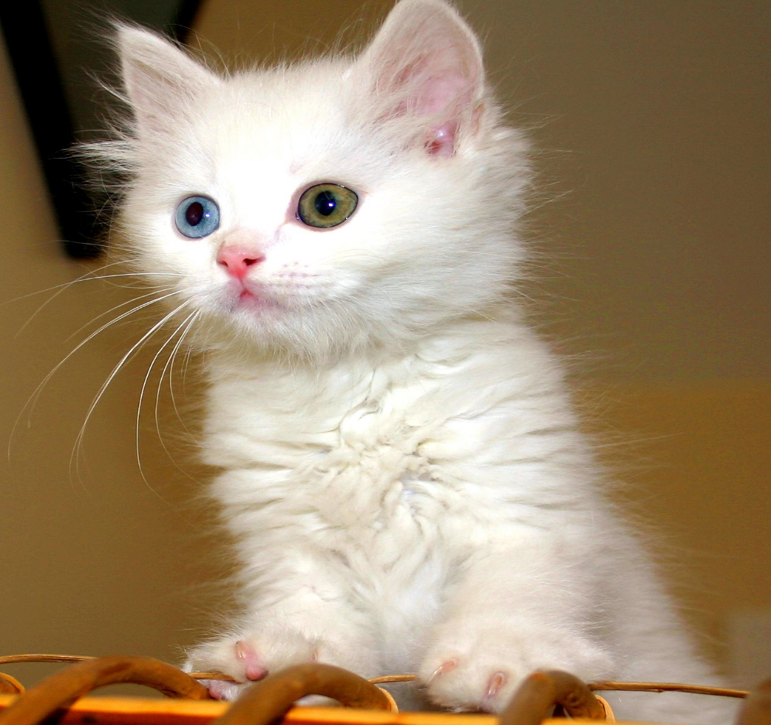

Source: <http://upload.wikimedia.org/wikipedia/commons/2/22/Turkish_Van_Cat.jpg>

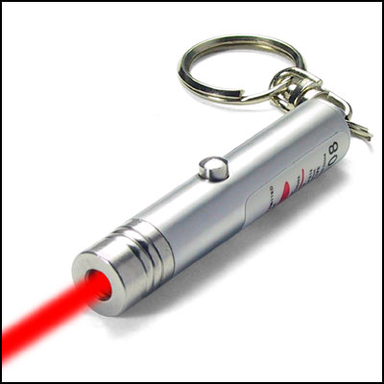

Source: <http://www.paranormalpeopleonline.com/wp-content/uploads/2014/01/red-laser-pointer-with-key-chain.jpg>

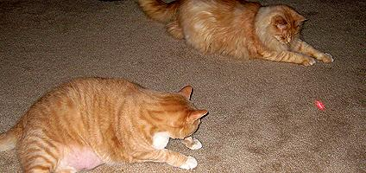

Source: <http://www.catster.com/files/styles/424_200sc/public/fields/cats-laser-pointers-HERO.jpg>

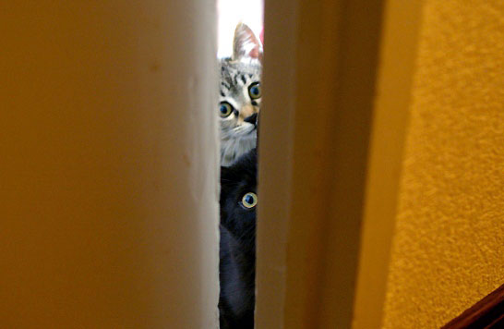

Source: http://lovemeow.com/wp-content/uploads/2011/06/20110531102513fa8.jpg